**Unit Mailroom Inspection Binder**

Updated: 2019 08 13 – MCB Quantico – SSgt Spoor D.R.

0201. Has the Commanding Officer appointed in writing a Unit Postal Officer and Assistant Postal Officer to supervise the operation of the Unit Mailroom?

**Reference: MCO 5110.6C, CHAP 1, PAR 3B-C, AND PAR 4A(1).**

Copy of Unit Postal Officer’s Appointment Letter

Copy of Asst. Unit Postal Officer’s (If applicable)

0202. Has the current Commanding Officer designated in writing all personnel authorized to receive and open all official mail to include accountable mail?

**Reference: MCO 5110.6C. CHAP 1, PAR 4A(1); CHAP 4, PAR 3A AND PAR 3C(1).**

Copy of Authorization Letter

0203. Has the Commanding Officer provided space and equipment necessary for proper mail handling and security?

Note: Personal items and other gear that is not related to the delivery or processing of mail are prohibited in the Unit Mailroom.

**Reference: MCO 5110.6C, CHAP 1, PAR 4A(1); CHAP 2, PAR 4; CHAP 3, PAR 1.**

Ensure there is enough space to conduct mail handing, and there is no personal items i.e. backpacks, DVD players or laptops etc.

0204. Are random unannounced inspections being conducted each week by the Unit Postal Officer or Assistant Postal Officer utilizing the current Inspectors General (IG) checklist?

**Reference: MCO 5110.6C. CHAP 1, PAR 4B(1); CHAP 2, PAR 6A.**

**IGMC Checklist Website:**

**https://www.hqmc.marines.mil/igmc/Resources/Functional-Area-Checklists/**

Keep all quarterly/CGIP inspections conducted by Postal Inspectors in this section and see separate “Weekly UMR Inspection Binder” for inspections that were conducted by Unit Postal Officer or Asst. Unit Postal Officer.

0205. Has the Unit Postal Officer, Assistant Postal Officer, mail clerks, and mail orderlies received the required training within 30 days of assuming mail handling duties?

**Reference: MCO 5110.6C, CHAP 1, PAR 4B (1-2), AND PAR 4B(1); CHAP 2, PAR 8.**

All training certificates kept in this section in order:

1. Unit Postal Officer Certificate
2. Asst. Unit Postal Officer Certificate

0206. Does the Unit Mailroom maintain a copy of the most current edition of the following publications/directives?

**Reference: MCO 5110.6C, CHAP 2, PAR 1.**

Option 1: Hard Copies can be kept in separate 3 ring binders.

Option 2: Digital Versions can be kept on a share drive.

* DOD 4525.6-M, DOD Postal Manual. – **Dated 15 August 2002**
* OPNAVINST 5112.6E, Navy Postal Instruction. – **Dated 22 October 2013**
* MCO 5110.6C, Conduct of Marine Corps Unit Mail Rooms and Mail Distribution Centers. – **Dated 21 January 2009**
* Base Order for Postal Affairs (5112.1B). – **Dated 2 June 2016**
* Unit Mail Handling Order. – **Unit’s Publish Date:** __________

0207. Has the command published a mail handling order that provides personnel with up-to-date information about local mail service and mail handling procedures within the unit? This order must include the following:

* The correct and complete mailing address used by personnel attached to the command.
* The location and hours of operation of the Unit Mailroom/MDC, and servicing post office.
* The location and collection hours for outgoing mail receptacles.
* Information about security of mail and postal effects.
* Procedures to establish a classified material screening point.
* Non-mail able items.
* Procedures for handling mail for personnel temporarily absent from the command.

**Reference. MCO 5110.6C, CHAP 2, PAR 2.**

Copy of Unit Mail Handling Order should also be kept in this section with each of the required information highlighted and/or tabbed off for easy verification.

0208. Is DD Form 1115, “Mail Room No Admittance Except to Authorized Personnel,” displayed on or near the entrance to the Unit Mailroom indicating hours of operation and an example of a correct personal and official mailing address for the command?

**Reference: MCO 5110.6C, CHAP 2, PAR 3.**

Type a copy of the Personal & Official Mailing address and post those outside the Unit Mailroom’s entrance.

Verify that the Hours Posted on the DD Form 1115 matches what is printed within the Unit’s Mail Handling Order.

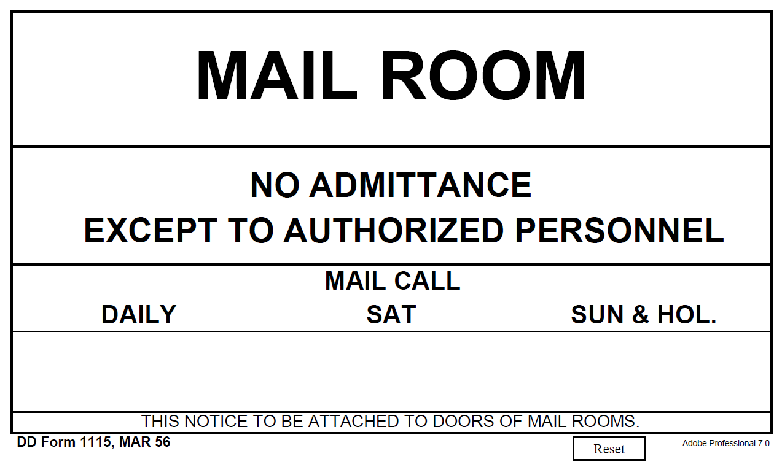

0209. Does the unit have a minimum of two Unit Mail Clerks and Mail Orderlies appointed per unit and section?

**Reference. MCO 5110.6C. CHAP 2, PAR 9.**

All Unit Mail Clerk training certificates kept in this section in order:

1. Unit Mail Clerk #1
2. Unit Mail Clerk #2
3. *Any Additional Unit Mail Clerks*

Unit Mail Clerk’s DD Form 285’s:

Make copies of this page as needed

Additional Unit Mail Clerk

Additional Unit Mail Clerk

Additional Unit Mail Clerk

Additional Unit Mail Clerk

Unit Mail Clerk #2

Unit Mail Clerk #1

**Unit Mail Orderlies** DD Form 285’s for _______________ (section)

Make copies of this page as needed

Additional Unit Mail Orderly

Additional Unit Mail Orderly

Additional Unit Mail Orderly

Additional Unit Mail Orderly

Unit Mail Orderly #2

Unit Mail Orderly #1

0210. Are DD Forms 285 and 2260 prepared, controlled and maintained?

**Reference. MCO 5110.6C, CHAP 2, PAR 8 AND PAR 9 A-B.**

Ensure Unit Mail Clerks and Orderlies DD Form 285’s are Properly Filled out and Matches what is on the DD Form 2260.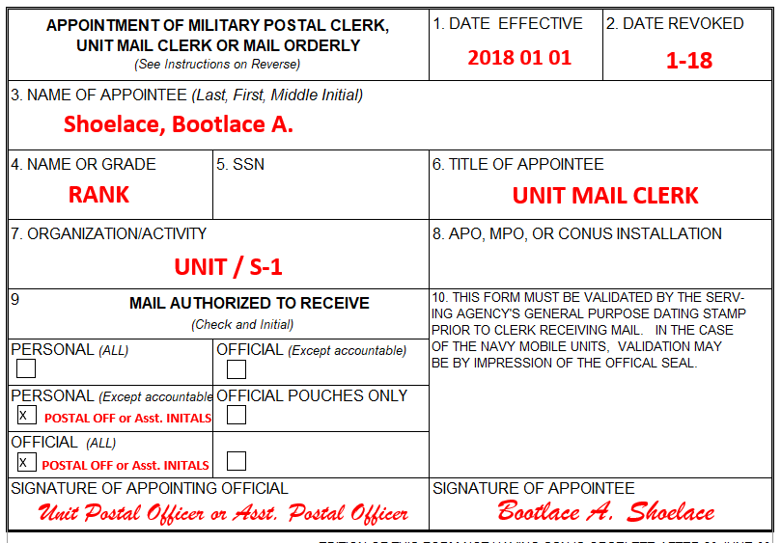

Unit Mail Clerk Example (RED)

Unit Mail Orderly Example (GREEN)

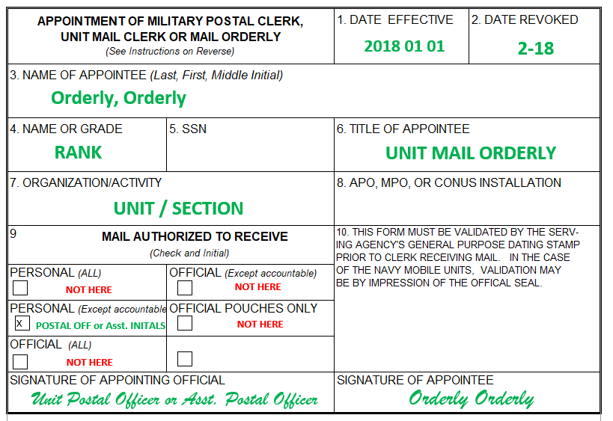

0211. Has personal mail been delivered to authorized section Mail Orderlies?

**Reference: MCO 5110.6C, chap 1, par 4d.**

0212. Do the mail clerks and orderlies have in their possession their DD Form 285 whenever performing mail handling duties?

**Reference. MCO 5110.6C, CHAP 2, PAR 9A.**

Ensure Unit Mail Clerks and Orderlies have their DD Form 285 on them while handling mail.

(Inspector will ask to see each Unit Mail Clerk’s DD Form 285 once they enter the Unit Mailroom)

0213. Are only authorized personnel allowed to enter the Unit Mailroom?

**Reference. MCO 5110.6C, CHAP 3, PAR 2.**

Ensure Unit Mail Clerks asks the Inspector for their Inspector’s Card (Prior to the beginning of the Inspection)

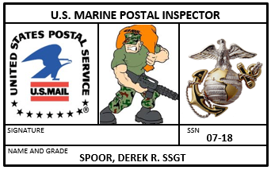

0214. Are keys to the Unit Mailroom being signed out by designated mail clerks utilizing a key control log and are duplicate keys or combinations being retained and secured in accordance with the reference?

**Reference: MC0 5110.6C, CHAP 3, PAR 3.**

Unit Mail Clerks should be signing out the keys from an appointed official via logbook or key sign in/out sheet.

Duplicate Key(s) to the Unit Mailroom should be kept secured with the Unit Postal Officer or Asst. Postal Officer.

Key should be inside a sealed envelope or PS Form 3977.

(Sealed Envelope example)

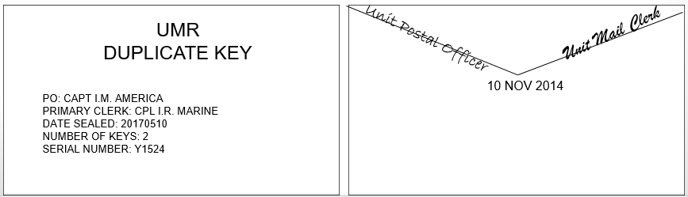

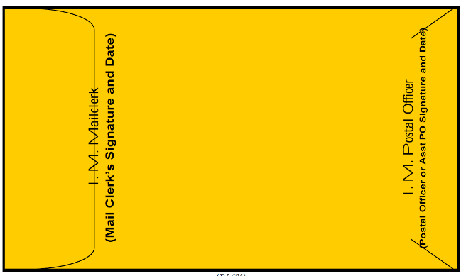(PS Form 3977 Example)

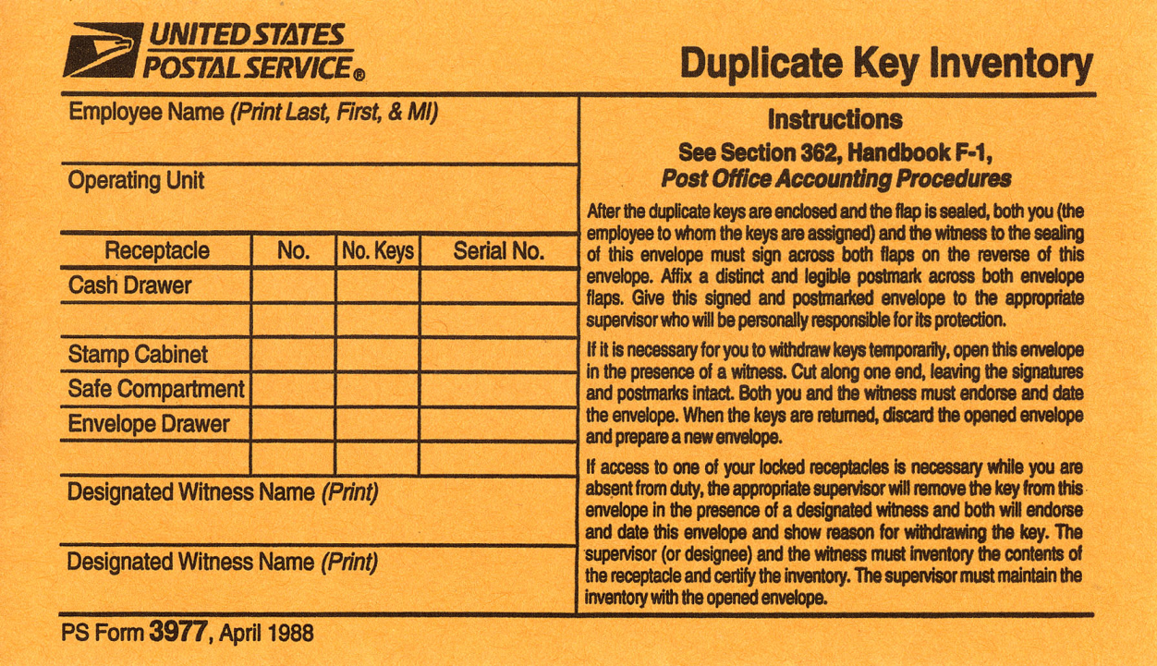

0215. Do the mail clerks understand the requirements for the security of the mail and the privileged nature of the mail and postal records?

**Reference. MCO 5110.6C, CHAP 3, PAR 1, AND 5.**

Unit Mail Clerks and Section Mail Orderlies shall safeguard mail in their possession at all times and may be held liable for failure to handle mail properly. The Unit Mailroom/MDC will be locked when the mail clerk is not present.

0216. Are the required protections given to the mail, in transit to and from the servicing post office?

**Reference. MCO 5110.6C, CHAP 3, PAR 4.**

“Commands shall transport all mail to and from the servicing postal facility area in a closed-body military vehicle equipped with lockable doors. If such a vehicle is unavailable, mail clerks or orderlies will ride in the compartment with the mail or at least maintain visual contact with the mail.” - Reference. MCO 5110.6C, CHAP 3, PAR 4.

0217. Do the mail clerks understand the detection and actions they must take for suspicious mail?

**Reference: MCO 5110.6C, CHAP 3, PAR 6; CHAP 4, PAR 2H.**

Each unit will prepare their own procedures.

At a minimum: Unit Mail Clerks and orderlies will immediately report any mail suspected of containing harmful matter or controlled substances to the Unit Postal Officer and servicing post office.

0218. Do mail clerks and orderlies understand the instructions on delivery of PS Form 3849,”Delivery Notice/Reminder/Receipt,” for personal accountable mail?

**Reference. MCO 5110.6C, CHAP 4, PAR 2B.**

The Unit Postal Officer must examine all mail on hand to include PS Form 3849s to ensure proper handling and delivery.





0219. Is all mail received from the servicing post office being back stamped by the mail clerk to show the date of receipt?

**Reference. MCO 5110.6C, CHAP 4, PAR 2D.**

The Unit Mail Clerks must date stamp the back of all mail received from the servicing post office showing date of receipt by the command.

0220. Is mail addressed to the Unit Mail Clerks handled in accordance with the reference?

**Reference: MCO 5110.6C, CHAP 2, PAR 5; CHAP 4, PAR 2E.**

Unit Mail Clerks’ personal mail should be handled and delivered in the same manner as the rest of unit mail.

0221. Do mail clerks understand all these instructions concerning the receipt and delivery of;

* Balloting material?
* Refused mail?
* Open by mistake?
* Mail received open, damaged, or missing contents?
* Mail for personnel TAD/leave?
* Mail for confined personnel?
* Casualty mail? Outgoing mail?
* Mail for Deserters?

**REFERENCE: MCO 5110.6C, CHAP 4, PAR 2, AND PAR 4-6; CHAP 6, PAR 3A(6)**

The Unit Postal Officer must ensure the Unit Mail Clerks are familiar with the receipt and delivery of all mail.

* Balloting material?

*A: Mail Clerks and Orderlies will give balloting material priority handling.*

* Refused mail?

*A: Addressees may refuse mail they do not want. The addressee will write on the front of the envelope or wrapper “REFUSED”, sign, and date it. IF the addressee declines to make the endorsement, the mail clerk/orderly will endorse it “REFUSED BY ADDRESSE”, sign, date, and return it to the servicing post office.*

* Open by mistake?

*A: When mail has been opened by mistake, the mail clerk/orderly will instruct the individual to reseal the envelope, endorse it “OPENED BY MISTAKE”, and sign it.*

* Mail received open, damaged, or missing contents?

*A: Mail that is received at the Unit Mailroom/MDC that is open, damaged, or missing contents will be endorsed with the appropriate endorsement by the mail clerk; “RECEIVED IN OPEN CONDITION”, “RECEIVED IN DAMAGED CONDITION”, “RECEIVED WITHOUT CONTENTS”, with the date of receipt and the identity of the unit endorsing the article of mail.*

* Mail for personnel TAD/leave?

*A: Mail for personnel on leave or TAD for 30 days or less will be held in the Unit Mailroom/MDC. The Unit Mailroom/MDC is required to maintain documentation on hand showing leave or TAD dates for all mail being held.**The service member must provide a letter to the Unit Mailroom/MDC providing a forwarding address, along with a stop date, and a signature of authorization to forward mail. This letter will be kept on file in the Unit Mailroom/MDC and will be destroyed when the service member returns.*

* Mail for confined personnel?

*A: Mail clerks will indicate a box number, building number, or other identification that does not indicate a confinement facility when forwarding mail to prisoners***.**

* Casualty mail? Outgoing mail?

*A: Under no circumstances will mail for casualties be returned to sender or forwarded to next of kin (NOK) until absolute verification is received that the next of kin have been notified. Once the NOK have been notified, the servicing Post Office will forward mail to the NOK, or return to sender per the wishes of the NOK. Verification can be obtained from the parent command*

* Mail for Deserters?

*A: When a service member is declared a deserter, return to sender all mail with the endorsement “Moved Left No Forwarding Address” (MLNFA). The mail clerk will enter the following information on the directory file card: write the word “Deserter” in the new duty station block, enter the desertion date, and discard date. The unit diary will be used as the source document for this entry. Enter the unit diary number in the appropriate block.*

0222. Has the command ensured personnel are checking in and out with the Unit Mailroom?

**Reference. MCO 5110.6C, CHAP 6, PAR 1.**

The command must ensure all personnel checks in and out with the Unit Mailroom in order to properly maintain the directory file cards, prevent mail delays and ensure the timely processing of all mail.

0223. Is there a chain of receipt for official accountable mail, from acceptance by the mail clerk through delivery to an authorized agent, and are delivery records (PS Form 3883) being properly completed, maintained, and verified by the Unit Postal Officer daily?

**Reference: MCO 5110.6C, CHAP 4, PAR 3C (2-7).**

The Unit Postal Officer will verify the proper use and completion of PS Form 3883 daily to ensure delivery has been made to an authorized agent.

0224. Are NAVMCs 10572 (Directory File Cards) completed, filed, and maintained as required?

**Reference: MCO 5110.6C, CHAP 6, PAR 3 AND PAR 5.**

The Unit Mail Clerks will fill out a NAVMC 10572 (Directory File Card) with information the service member provides when checking in or checking out.

When a service member temporarily leaves the unit, the Unit Mail Clerk must update the directory file card with the duty status to ensure proper delivery service or retention of mail is documented.

0225. Are mail clerks providing directory service for all Undeliverable-as-Addressed mail to include Forwarded, No Record, Missing, and Moved Left No Address mail and is the mail endorsed?

**Reference: MCO 5110.6C, CHAP 4, PAR J2; CHAP 6, PAR 1-3A(1) AND PAR 4.**

0226. Are mail clerks provided with a copy of the unit diary, morning report, or other source documents for updating directory file cards for individuals that do not or cannot provide this information?

**Reference: MCO 5110.6C, CHAP 6, PAR 5**

Ensure all Unit Mail Clerks are provided with an updated copy of unit diary, morning report, or other source documents.

0227. If mail delivery is through delivery receptacles, is the unit in compliance with questions 0145-0151?

**Reference: MCO 5110.6C, CHAP 5.**

**No Units on MCB Quantico has delivery receptacles.**

0238. Is mail delivery being delayed?

**Reference: DOD 4525.6-M, CHAP 15, PAR C15.10.2.**

Unit Mailroom should be checked weekly to ensure there is not mail past 30 Days inside the Unit Mailroom.

0229. Are Commanders of mobile units providing the serving Post Office with proper mail routing information in a timely manner?

**Reference: DOD 4525.6-M, C11.5.2.2.1.**

**No Units on MCB Quantico have mobile units.**

**Unit Official Mail Program Inspection Binder**

Updated: 2019 08 13 – MCB Quantico – SSgt Spoor D.R.

0301. Has the unit established an Official Mail Center in order to monitor the Official Mail Program (OMP)?

**Reference: MCO5110.4A, CHAP 4, PAR 2A.**

Typically the Official Mail Center is located in the Unit’s S-1

0302. Is official mail being delivered to only authorized agents designated in writing by the current Commanding Officer?

Note: This applies to units with or without a mailroom.

**Reference: MCO5110.4A, CHAP 4, PAR 3A.**

Copy of Authorization Letter

Official mail must be delivered daily to an authorized agent. It will be delivered only to personnel authorized in writing to receipt for official mail, or authorized on a DD Form 285. It will be opened only by personnel authorized in writing to do so. All mail addressed to the "Commanding Officer" or the "Commanding Officer of_____" is considered official mail.

0303. Has the Command Appointed Personnel in the grade of E-6 or GS-9 or above as the Unit Official Mail Manager?

(Note: An Assistant Official Mail Manager is highly recommended in order to perform the Official Mail Manager duties when the Official Mail Manager is absent).

**Reference. DODI 4525.09, SECT 3, PAR 3.2.G.**

Copy of Unit’s Official Mail Manager’s Appointment Letter

Copy of Unit’s Asst. Official Mail Manager’s Appointment Letter

(If Applicable)

0304. Does the unit Official Mail Manager have current copies of all publications required?

* DODI 4525.09, DoD Military Postal Service
* DOD 4525.8-M, DoD Official Mail Manual.
* MCO 5110.4A, Marine Corps Official Mail Program.

Note: Electronic versions of these publications are authorized.

**Reference: MCO 5110.4A, CHAP 6, PAR 1.**

Option 1: Hard Copies can be kept in separate 3 ring binders.

Option 2: Digital Versions can be kept on a share drive.

* DODI 4525.09, DoD Official Mail Management. **– Dated 10 July 2018**
* DOD 4525.8-M, DoD Official Mail Manual. **– Dated 26 December 2001**
* MCO 5110.4A, Marine Corps Official Mail Program. **– Dated 21 January 2009**

0305. Is official mail being consolidated?

**Reference: DOD 4525.8-M, CHAP 2, PAR C2.10.**

Consolidated mailings shall be made when they are cost-effective. Consolidated mailings are a reliable way to ship administrative and operational communications and logistical items between headquarters, depots, contractors, installations, and operational units.

0306. Does the Unit Official Mail Manager understand the proper guidelines for the use of special service?

**Reference: DOD 4525.8-M, CHAP 1, PAR C1.8.**

The Unit Official Mail Manager must ensure the use of special services are limited to when law or DoD Regulation requires them or when mission essential.

0307. Is outgoing official mail addressed and formatted in accordance with the reference?

**Reference: MCO 5110.4A, CHAP 1, PAR 5.**

All mail shall be prepared and packaged according to USPS regulations. To ensure the most efficient delivery of mail, a correctly formatted, current mailing address must be used. Refer to reference for proper addressing guidelines and standards.

0308. Is the Unit Official Mail Manager carrying out the official mail program supervision requirements?

**Reference: DODI 4525.09, CHAP 3, PAR 3.2.G.**

The appointed Official Mail Manager must supervise mailing practices and report misuse of official mail to the commanders of alleged violators.